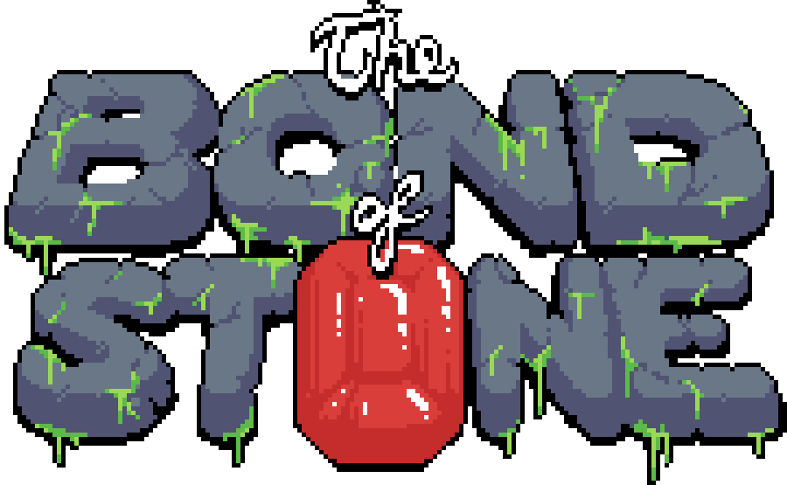

*A Game by Incredible Rock Studios*

***User Manual***

The Bond of Stone is a game set on a faraway planet made entirely of a giant sea. The lands of this world are colossal, sentient beings made of stone and minerals. Various creatures live on and in these Titans, and are by association subject to the Titans’ independent will and warlike tendencies.

In a great battle, the Titan Tyche was slain by the Titan Nemesis. The Tychans were nearly all wiped out, and cast into the sea. Pieces of Tyche were flung to the heavens, kept aloft by the presence of the Bonds – minerals with latent power which allow the Titans to function – which remained hidden among the pieces.

Along with the pieces were several surviving Tychans. Their only hope of reclaiming their homeland is to find the remaining Bonds of Tyche and drive out the Nemesians.

*The in-game instructions, accessible through the question mark button on the main menu, are transcribed here:*

Use the left and right arrow or A and D keys to move. Use the spacebar, the up arrow key, or the W key to jump. Move against a wall while midair to wall jump. Jump on the heads of the Nemesians to destroy them. Collect coins to increase your score multiplier. Miss a coin, and your multiplier goes away. Collect Bonds of Tyche (red gems) to restore some health.

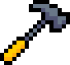

***External Tool: Map Manager***

The Map Manager is a tool packaged with The Bond of Stone which allows users to easily manipulate the chunks that are used for level generation in game.

*This is the interface of the Map Manager. You’ll notice that nothing is displayed in the “Loaded Maps” box or in the “Selected Map” panel.* ***The first thing to do*** *is direct the manager to your personal maps directory by first clicking the Options button.*

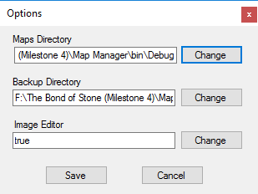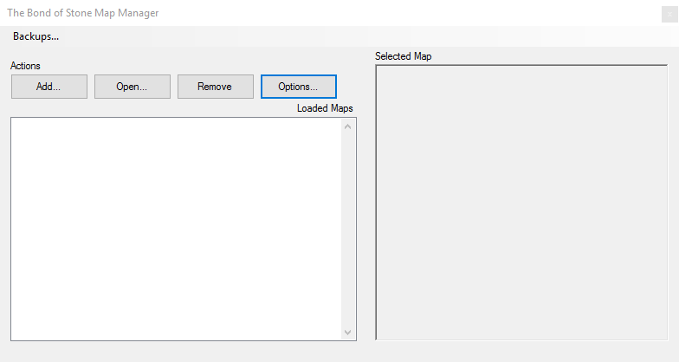

*In the Options menu, you can direct the manager to your maps and backups directories, as well as set a default image editor. Make sure to click the Save button to save these preferences.*

*The maps folder is in the game’s main directory, in Content\maps. The default backup location is in Content\maps_backup, but this can be set to anywhere on your computer.*

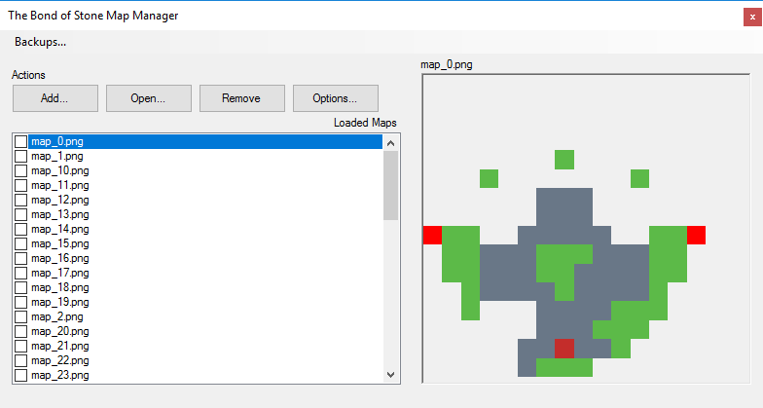

*Once the maps directory is set properly, the maps will appear in the “Loaded Maps” box. Selecting a map will show it in the “Selected Map” panel. From here, you can use the Add button to add a map from the file system to the maps directory, open the selected map in the defined image editor, remove the selected map from the maps directory, or make and load from backups.*

***Operations like remove and load from backup are permanent****, and generally unsafe, as all the maps from the file system could be deleted with no recourse, which would result in a very boring game.* ***Be careful, and make use of the backup system!***

**

***Creating your Own Maps***

Part of the fun of The Bond of Stone is using the Map Manager to implement your own custom maps. The game reads chunk data from individual image files whose pixel data corresponds to in game tiles (1 pixel = 1 tile).

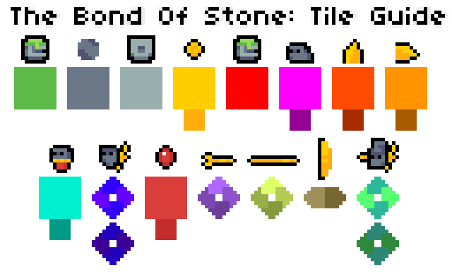In the game directory, you will find a file called “TILE_GUIDE” which contains all the color data for the tiles in game. Here, you can read a more detailed description of the tiles.

From left to right, top to bottom:

1. ***Ground Tile.*** This is the stock terrain tile for the game. It’s solid, and can be traversed ‘normally’ by the player.
2. ***Background Tile.*** This is a non-walkable tile which appears behind the rest of the game world. It is used as decoration.
3. ***Ruins Tile.*** This functions the same as the ground tile. It is only graphically different.
4. ***Coin.*** This is a coin, which the player can collect to increase their multiplier. The darker color beneath the main color can be used to spawn a coin with a Background Tile behind it. This applies to all the other entities with darker alternate colors.
5. ***Start/End Tile.*** EVERY MAP FILE must have one Start/End Tile in the left and right column of the image in order for the map to load correctly. Failure to do this will result in instability.
6. ***Ground Nemesian.*** A simple enemy that traverses terrain left to right, switching direction when it hits a wall or gap.
7. ***Vertical Spike.*** A non-walkable static hazard which harms the player when touched. Place the Vertical Tile beneath or above a terrain tile.
8. ***Horizontal Spike.*** A non-walkable static hazard which harms the player when touched. Place the Horizontal Spike to the left or right of a terrain tile.
9. ***Jumping Nemesian.*** Another enemy, which hops vertically in place. Its jumps are 2 ½ tiles high.
10. ***Flying Nemesian.*** Another enemy, which traverses horizontally or vertically (the blue color signifies vertical traversal, and the purple horizontal). It travels 6 tiles in either direction before switching direction and patrolling back the way it came. It also switches direction when it hits a wall.
11. ***Bond of Tyche.*** This pickup heals the player.
12. ***Arrow Trap.*** This hazard fires arrows periodically in a straight line. This static entity spawns a walkable terrain tile behind it by default, so it should be placed flush with the terrain of a map. The directional indicators in the tile guide show which way the trap will point.
13. ***Spear Trap.*** When the player gets close to this trap, a spear will shoot out. This static entity spawns a walkable terrain tile behind it by default, so it should be placed flush with the terrain of a map.
14. ***Sawblade Launcher.*** This trap will periodically launch a fast-moving, spinning sawblade, which hurts the player if it comes in contact with it. This static entity spawns a walkable terrain tile behind it by default, so it should be placed flush with the terrain of a map.
15. ***Nemesian Warrior.*** This enemy has the behavior of the Flying Nemesian, and also throws spears at the player.

***General Mapmaking Style Guide***

* Make sure your map has a start and end tile.
* Organically-shaped terrain looks better when you use the Ground Tile. More geometric, angular terrain looks better when using the Ruins Tile.
* Background Tiles add lots of depth to your map.
* Every map should be able to be completed, and all pickups collected, without taking any damage.
* Liberal use of enemies is not as effective as efficient use of enemies.
* Multiple paths through maps make them much more interesting.
* Coins and Bonds should generally lie on more difficult paths.
* Enemies can be used to reach higher terrain.
* Make sure to implement areas where the player is encouraged to wall jump and maneuver creatively.
* The best maps are those which are between 15 and 30 tiles in either direction. Maps are not technically bound to any dimensions.
* The best program we have found to use for mapmaking is Paint.NET.
* Any color used that is not explicitly in the tile guide will appear in game as an air tile.